**EXPERIMENT:7**

**AIM: FIND THE BLOGS WHICH TAKE PEOPLE TO THIS SITE.**

**Search engine optimization**

**Potential customers must be able to find your store using search engines. That’s why Shopify supports SEO best practices like customizable H1, title and meta tags.**

**Shopify also automatically generates sitemaps.xml files so new products and site changes show up on search engines quickly.**

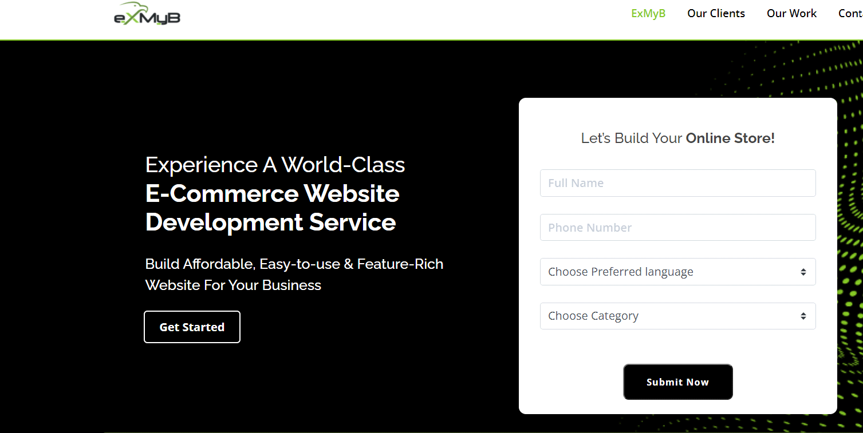

**Start accepting orders in minutes**

**Shopify includes everything you need to set up your business website and start selling online.**

**It’s quick and easy to choose a theme, add your products, and begin accepting orders. You could make your first sale the same day you sign up!**

**Extend the functionality of your storefront**

**Shopify apps are a fast, easy way to add useful extra features to your website.**

**Apps give your store an edge over the competition by increasing your marketing capabilities, making your shop even easier to manage, improving your SEO, helping you track sales trends, and more.**

**Detailed customer profiles**

**The Customer area in your shop admin lets you learn more about your customers and their shopping habits. You can find their contact info and order history at a glance.**

**Create customer groups**

**It’s easy to be organized with Shopify! Categorize and export customer lists based on location, purchase history, and more.**

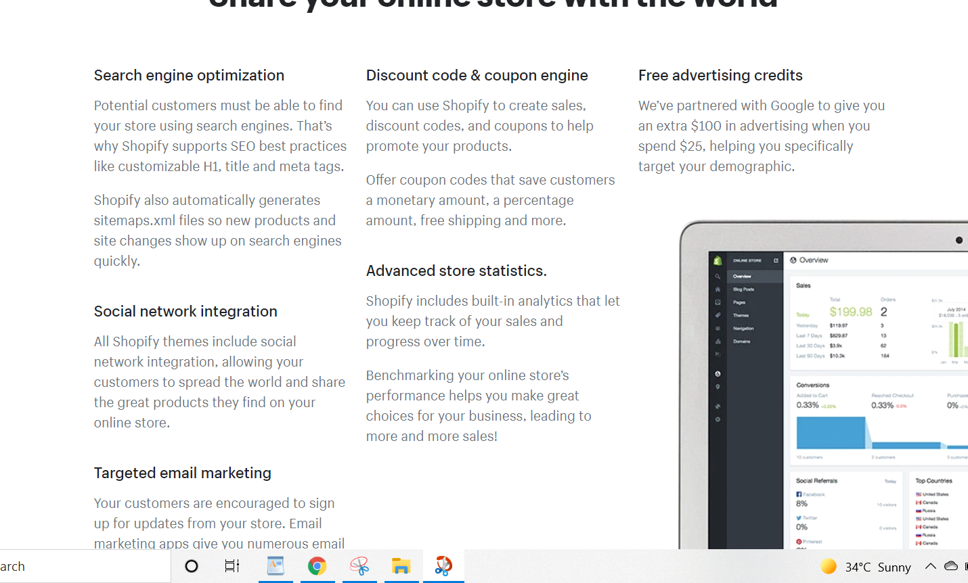

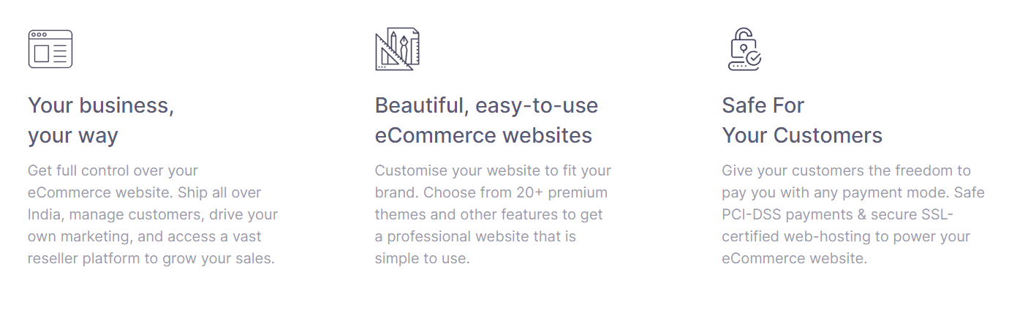

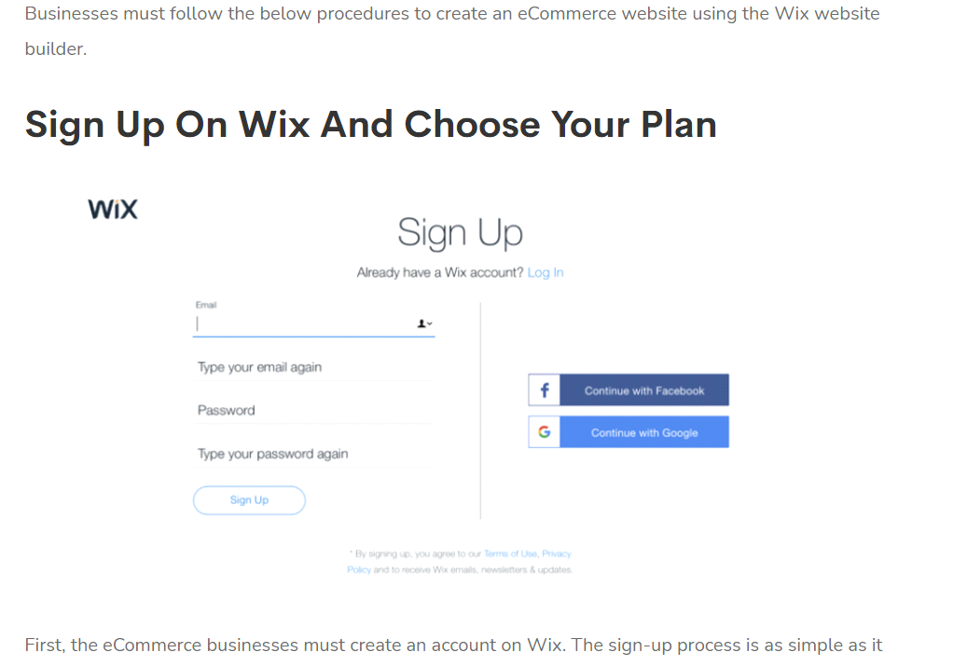

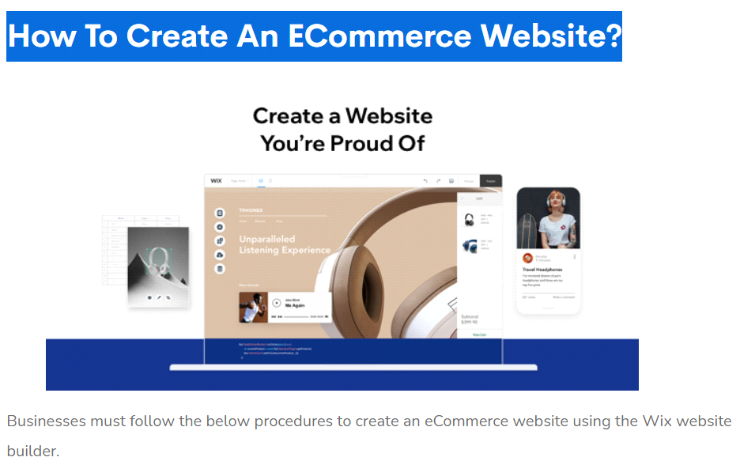

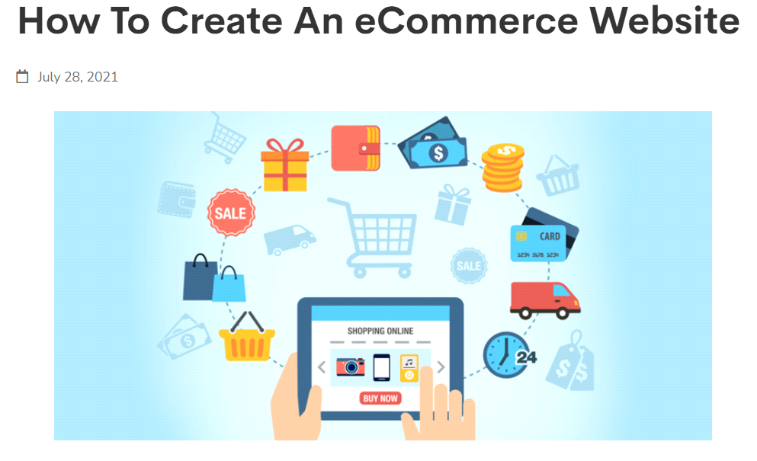

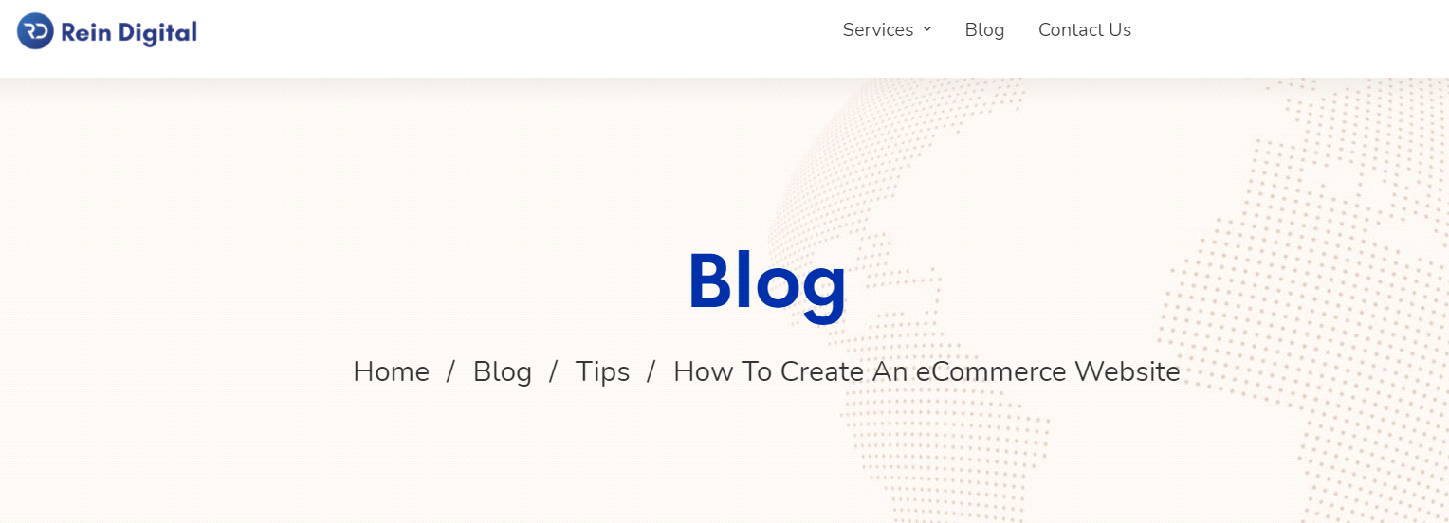

**How to Start a Blog in 6 Steps**

**Pick a blog name. Choose a descriptive name for your blog.**

**Get your blog online. Register your blog and get hosting.**

**Customize your blog. Choose a free blog design template and tweak it.**

**Write & publish your first post. Share your thoughts with the world. The fun part!**

**Promote your blog. Get more people to read your blog with the proper marketing.**

**Make money blogging. Choose from several options to monetize your blog.**



**CONCLUSION: In this experiment we learned about the page and create your site load time and perform practical to find the page load time for website as well as we came to know about how the componets of the page load and how much time taken to load them.find your blog and creat a website.How to Start a Blog in 6 Steps**